Debugging document

ITC205_Assignment Item 4

CSU SYDNEY STUDY CENTRE

Professional Programming Practice

**Table of Contents**

**Replication** 3

1. Produce Random Dice Values 3

2. Game Pay Out at Correct Level 4

3. Game Ends When Reached Betting Limit 5

4. Odds in The Game Appears To Be Correct 6

**Simplification** 7

1. Produce Random Dice Values 7

Testing Target Code 7

Current Result 7

2. Game Pay Out at Correct Level 8

Testing Target Code 8

Current Result 8

3. Game Ends When Reached Betting Limit 9

Testing Target Code 9

Current Result 9

4. Odds in The Game Appears To Be Correct 10

Testing Target Code 10

Current Result 10

**Tracing** 11

1. Produce Random Dice Values 11

Automated Testing Class and method 11

Testing Result 11

Origin of bug found 12

2. Game Pay Out at Correct Level 13

Automated Testing Class and method 13

Testing Result 13

Origin of bug found 14

3. Game Ends When Reached Betting Limit 15

Automated Testing Class and method 15

Testing Result 15

Origin of bug found 16

4. Odds in The Game Appears To Be Correct 17

Automated Testing Class and method 17

Testing Result 17

Origin of bug found 18

**Resolution** 19

1. Produce Random Dice Values 19

Fixed Code 19

Fixed Output 19

2. Game Pay Out at Correct Level 20

Fixed Code 20

Fixed Output 20

3. Game Ends When Reached Betting Limit 21

Fixed Code 21

Fixed Output 21

4. Odds in The Game Appears To Be Correct 22

Fixed Code 22

Fixed Output 22

# **Replication**

## 1. Produce Random Dice Values

|  |  |  |  |  |  |
| --- | --- | --- | --- | --- | --- |
| **Test Name** | | Produce random dice values | | | |
| **Use Case Tested:** | |  | | | |
| **Test Description:** | | Check if application produce random Dice Value properly | | | |
| **Pre-conditions** | | DiceValue Class is ready and set for producing randomized dice values | | | |
| **Post-conditions** | | In each game, random set of 3 dice values has to be produced | | | |
| **Notes:** | | *Test step would be just running Application as game starts as soon as application run* | | | |
| **Result**  **(Pass/Fail/Warning/Incomplete)** | | Fail | | | |
|  | **Test Step** | **Expected Test Results** | **Actual Results** | **P** | **F** |
| 1. | Run Application | Produce random dice values for each turn of a game | Produced same values for every turn of games |  | **X** |
| 2. |  |  |  |  |  |
| 3. |  |  |  |  |  |

|  |  |  |  |  |  |
| --- | --- | --- | --- | --- | --- |
| **Test Data Table** | | | | | |
|  | **1** | **2** | **3** | **4** | **5** |
| **Player (Domain)** | Player.name = “Fred”; (String) | Player.limit = 0;  (int) | Player.balance = 100; (int) |  |  |
| **bet** | bet = 5; |  |  |  |  |
| **DiceValue** | *CROWN*, *ANCHOR*, *HEART*, *DIAMOND*, *CLUB*, *SPADE*; |  |  |  |  |
| **limit** | limit = 0; (int) |  |  |  |  |

## 2. Game Pay Out at Correct Level

|  |  |  |  |  |  |
| --- | --- | --- | --- | --- | --- |
| **Test Name** | | Game pay out at correct level | | | |
| **Use Case Tested:** | |  | | | |
| **Test Description:** | | Check if application pay winning prize at correct level | | | |
| **Pre-conditions** | | Game Class is ready and set for producing winning prize value | | | |
| **Post-conditions** | | Game pays Player at correct level based on amount of bet | | | |
| **Notes:** | | *Test step would be just running Application as game starts as soon as application run* | | | |
| **Result**  **(Pass/Fail/Warning/Incomplete)** | | Fail | | | |
|  | **Test Step** | **Expected Test Results** | **Actual Results** | **P** | **F** |
| 1. | Run Application | Pay Player when player win | Paid Player when player won | **X** |  |
| 2. | Run Application | Winning prize is correct | Winning prize does not include the money that Player bet |  | **X** |
| 3. |  |  |  |  |  |

|  |  |  |  |  |  |
| --- | --- | --- | --- | --- | --- |
| **Test Data Table** | | | | | |
|  | **1** | **2** | **3** | **4** | **5** |
| **Player (Domain)** | Player.name = “Fred”; (String) | Player.limit = 0;  (int) | Player.balance = 100; (int) |  |  |
| **bet** | bet = 5; (int) |  |  |  |  |
| **DiceValue** | *CROWN*, *ANCHOR*, *HEART*, *DIAMOND*, *CLUB*, *SPADE*; |  |  |  |  |
| **limit** | limit = 0; (int) |  |  |  |  |

## 3. Game Ends When Reached Betting Limit

|  |  |  |  |  |  |
| --- | --- | --- | --- | --- | --- |
| **Test Name** | | Game ends when reached betting limit | | | |
| **Use Case Tested:** | |  | | | |
| **Test Description:** | | Check if game ends when reached betting limit | | | |
| **Pre-conditions** | | Limit to be set | | | |
| **Post-conditions** | | Game ends when Player reached limit | | | |
| **Notes:** | | *Test step would be just running Application as game starts as soon as application run* | | | |
| **Result**  **(Pass/Fail/Warning/Incomplete)** | | Fail | | | |
|  | **Test Step** | **Expected Test Results** | **Actual Results** | **P** | **F** |
| 1. | Run Application | Game ends when reached Player’s limit | Game ended when Player still could bet one more time |  | **X** |
| 2. |  |  |  |  |  |
| 3. |  |  |  |  |  |

|  |  |  |  |  |  |
| --- | --- | --- | --- | --- | --- |
| **Test Data Table** | | | | | |
|  | **1** | **2** | **3** | **4** | **5** |
| **Player (Domain)** | Player.name = “Fred”; (String) | Player.limit = 0;  (int) | Player.balance = 100; (int) |  |  |
| **bet** | bet = 5; |  |  |  |  |
| **DiceValue** | *CROWN*, *ANCHOR*, *HEART*, *DIAMOND*, *CLUB*, *SPADE*; |  |  |  |  |
| **limit** | limit = 0; (int) |  |  |  |  |

## 4. Odds in The Game Appears To Be Correct

|  |  |  |  |  |  |
| --- | --- | --- | --- | --- | --- |
| **Test Name** | | Odds in the game appears to be correct | | | |
| **Use Case Tested:** | |  | | | |
| **Test Description:** | | Check if the application produce correct winning ratio | | | |
| **Pre-conditions** | | Successfully get random dice values | | | |
| **Post-conditions** | | Winning ratio should approximately equal to 42% | | | |
| **Notes:** | | *Test step would be just running Application as game starts as soon as application run* | | | |
| **Result**  **(Pass/Fail/Warning/Incomplete)** | | Fail | | | |
|  | **Test Step** | **Expected Test Results** | **Actual Results** | **P** | **F** |
| 1. | Run Application | Winning ratio is approximately about 42% | Winning ratio seems to be 50% |  | **X** |
| 2. |  |  |  |  |  |
| 3. |  |  |  |  |  |

|  |  |  |  |  |  |
| --- | --- | --- | --- | --- | --- |
| **Test Data Table** | | | | | |
|  | **1** | **2** | **3** | **4** | **5** |
| **Player (Domain)** | Player.name = “Fred”; (String) | Player.limit = 0;  (int) | Player.balance = 100; (int) |  |  |
| **bet** | bet = 5; |  |  |  |  |
| **DiceValue** | *CROWN*, *ANCHOR*, *HEART*, *DIAMOND*, *CLUB*, *SPADE*; |  |  |  |  |
| **limit** | limit = 0; (int) |  |  |  |  |

# **Simplification**

## 1. Produce Random Dice Values

### Testing Target Code

while (player.balanceExceedsLimitBy(bet) && player.getBalance() < 200)  
{  
 cdv = game.getDiceValues();  
   
 System.*out*.printf("Rolled %s, %s, %s\n",  
 cdv.get(0), cdv.get(1), cdv.get(2));  
 }

### Current Result

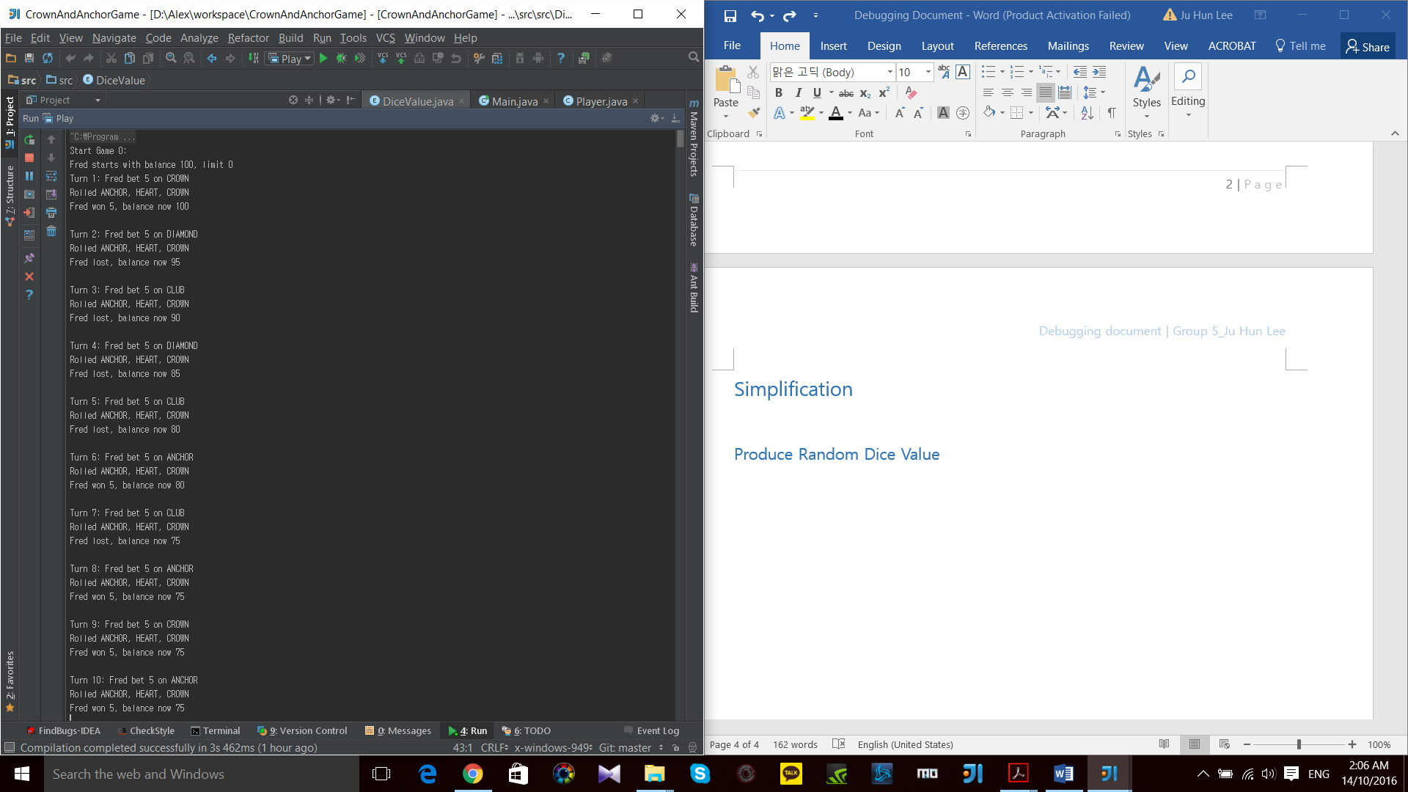

**\* Buggy Behavior: Producing a same set of 3 dices’ value for each turn and each game.**

## 2. Game Pay Out at Correct Level

### Testing Target Code

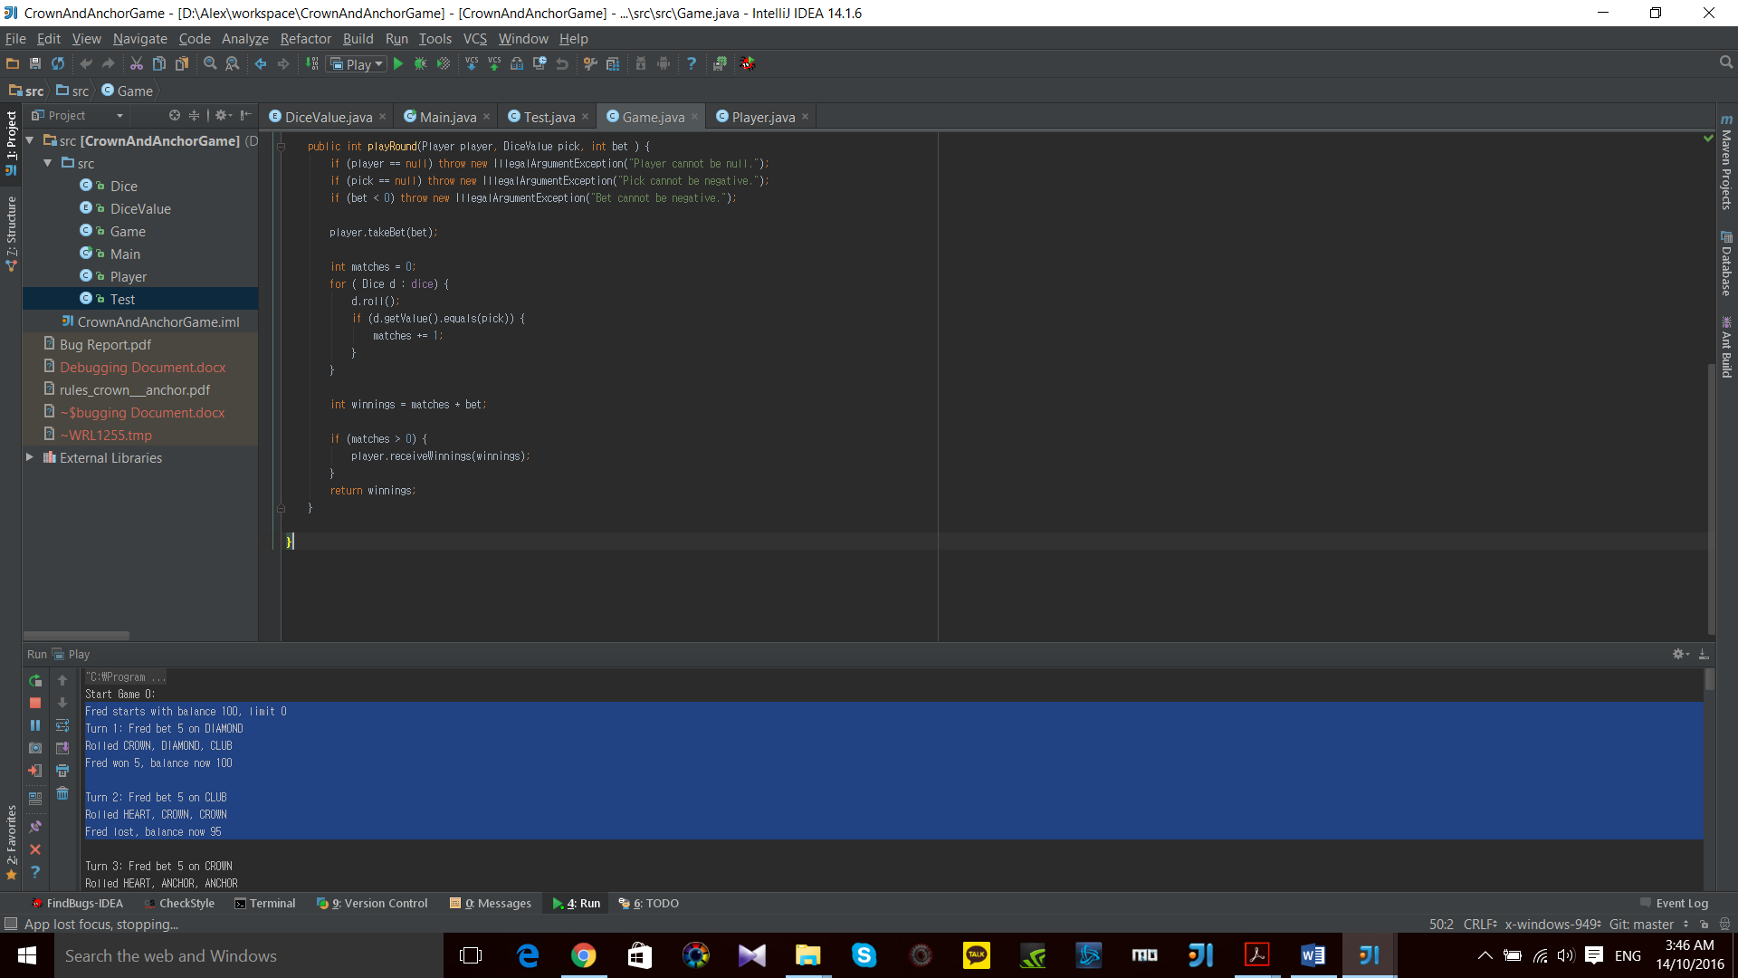

### Current Result

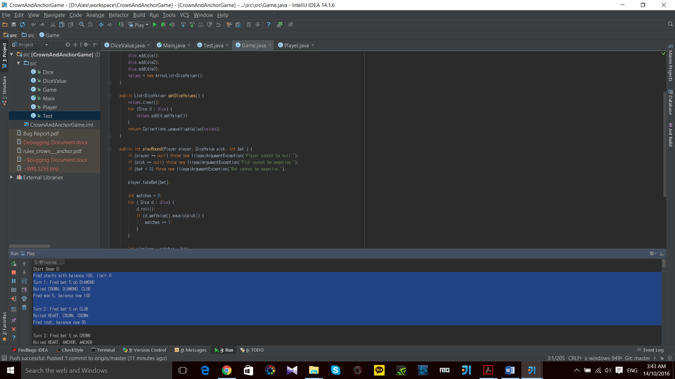

**\* Buggy Behavior: Winning prize does not pay back the bet of turns.**

## 3. Game Ends When Reached Betting Limit

### Testing Target Code

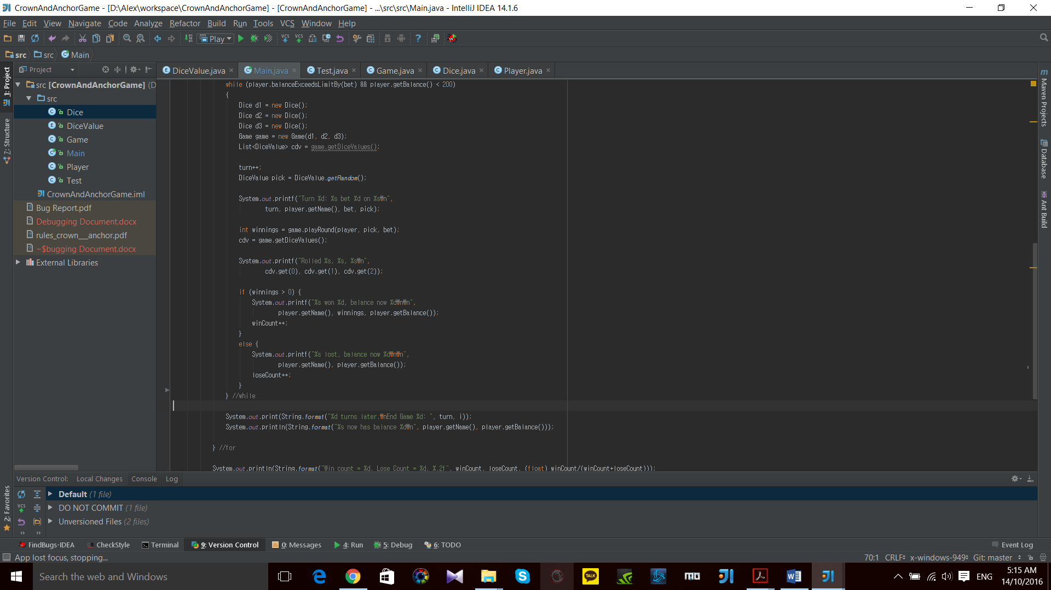

### Current Result

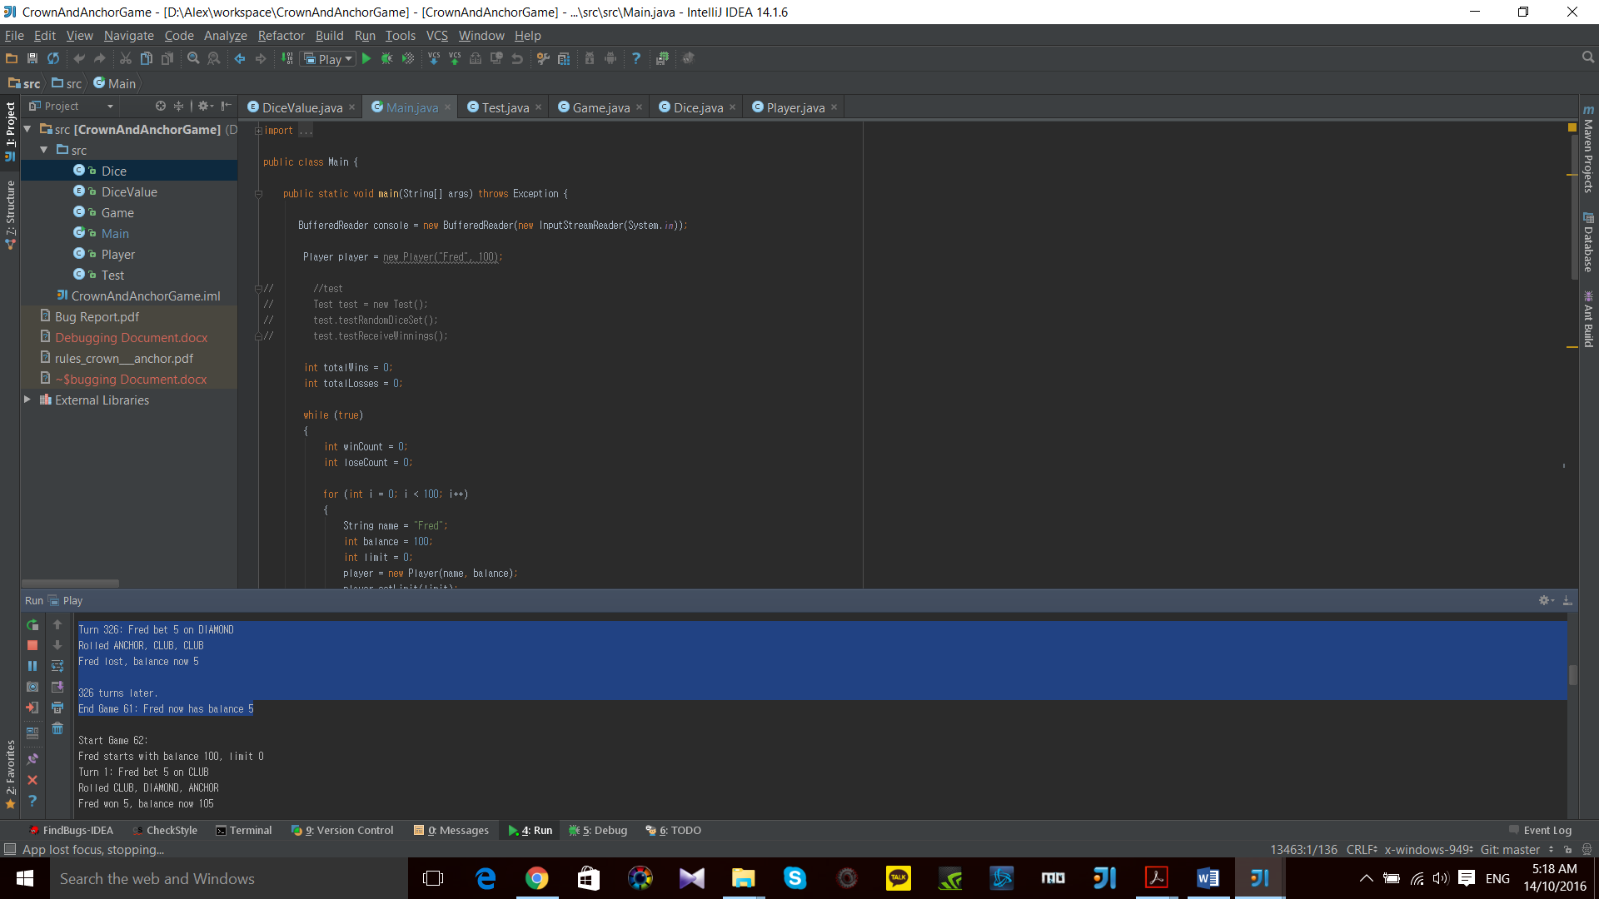

**\* Buggy Behavior: Game ends when Player still has enough balance for another turn.**

## 4. Odds in The Game Appears To Be Correct

### Testing Target Code

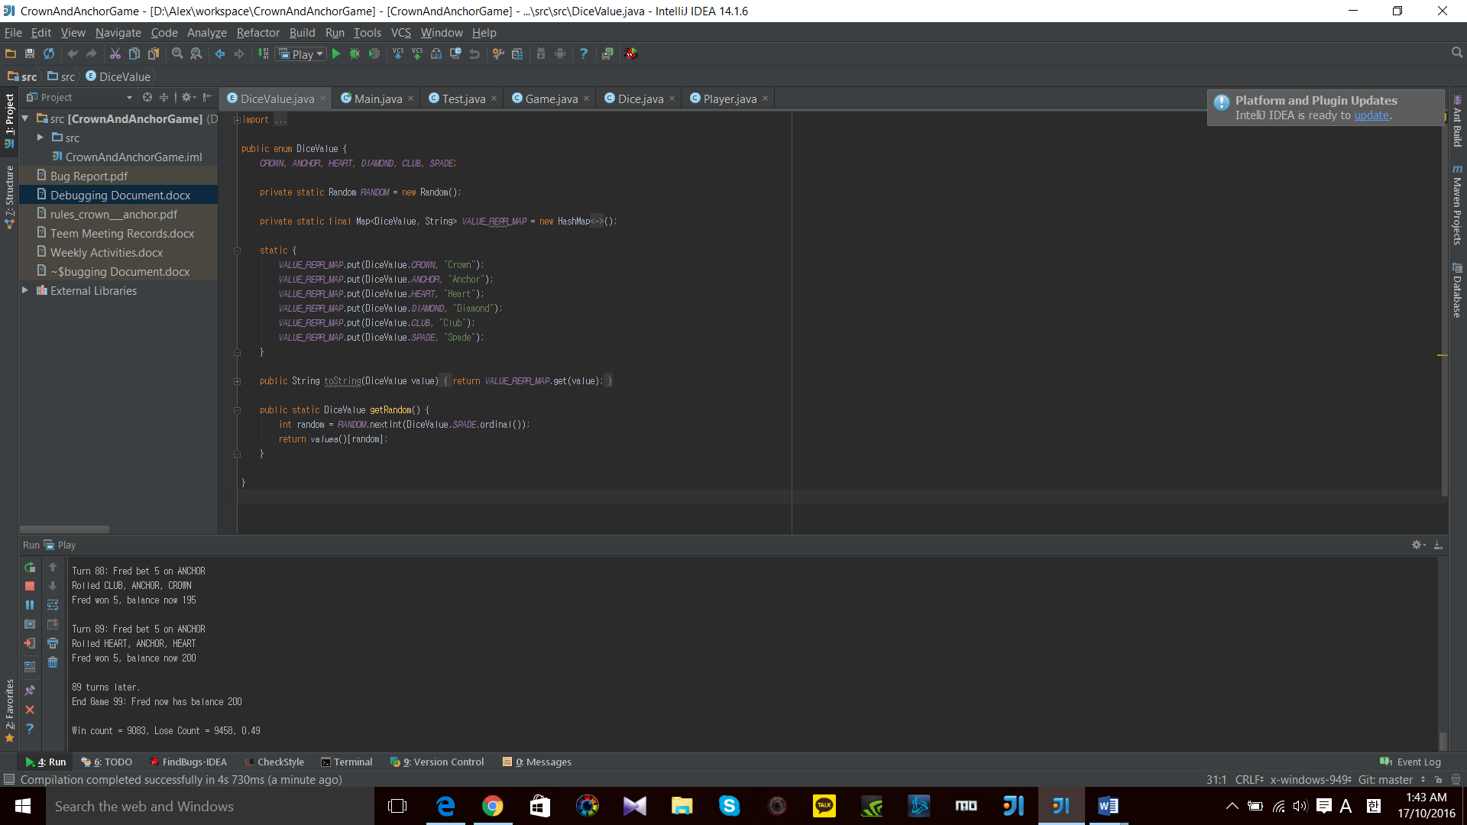

### Current Result

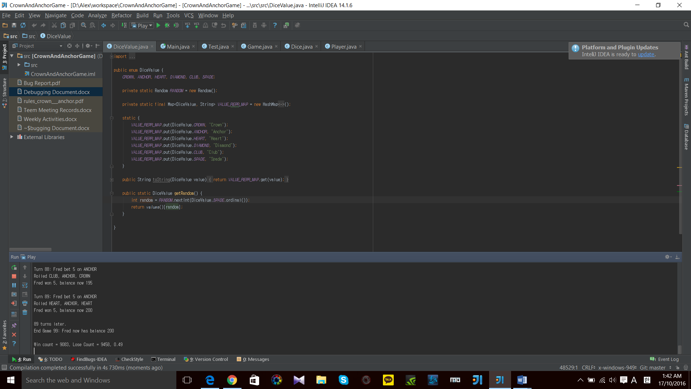

# **Tracing**

## 1. Produce Random Dice Values

### Automated Testing Class and method

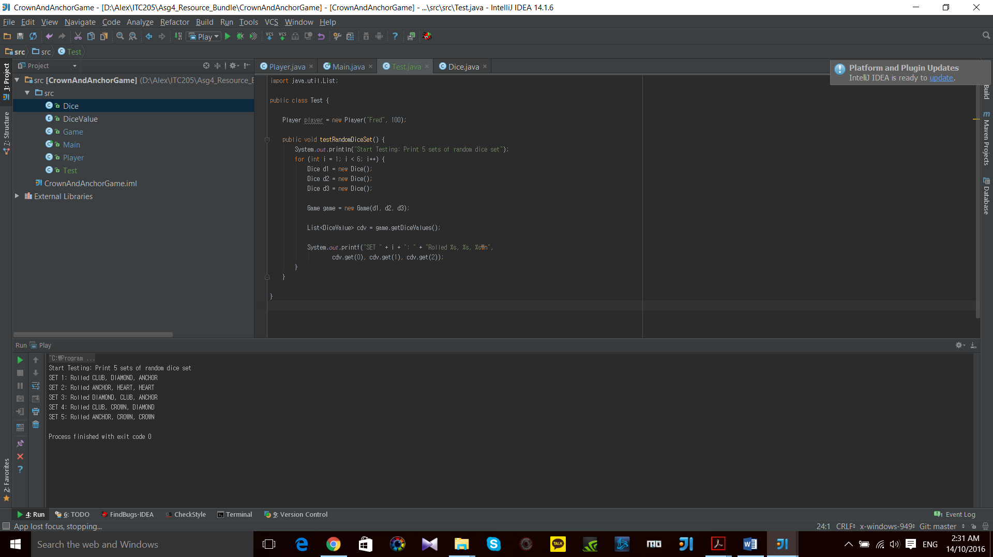

### Testing Result

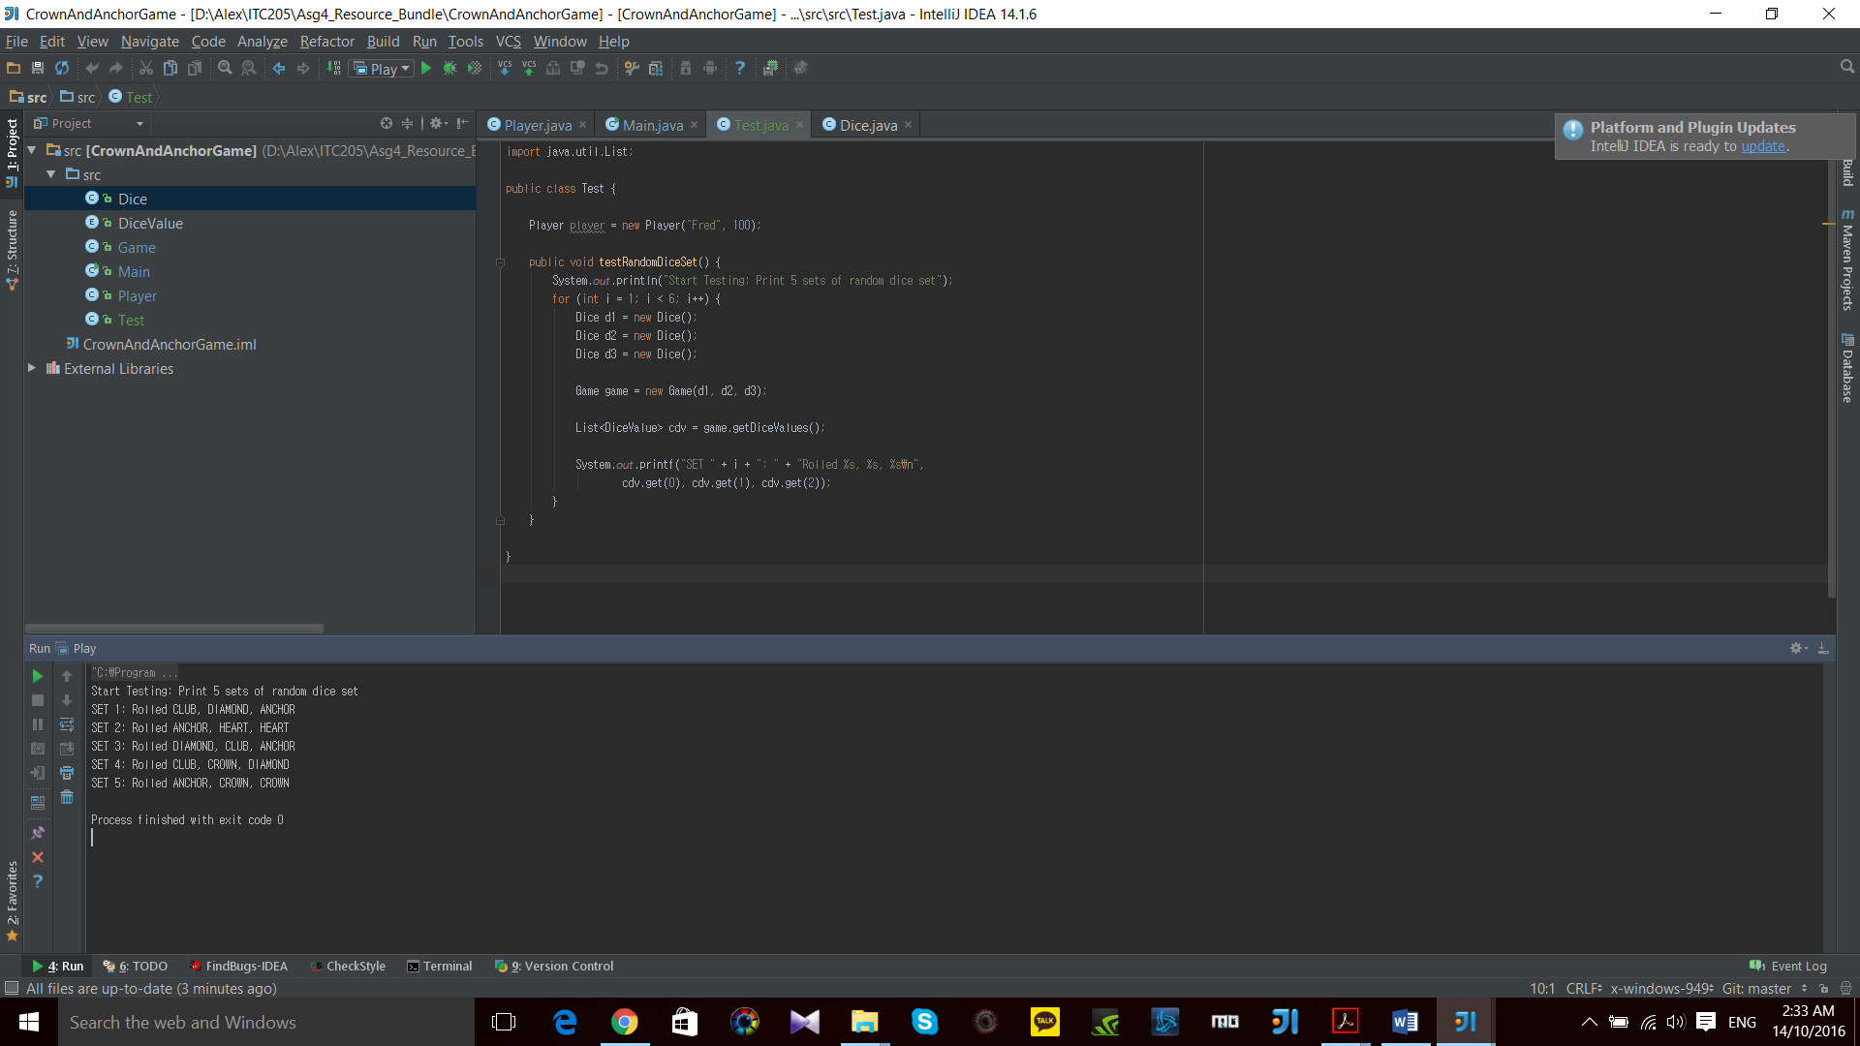

**\* Producing a set of random dice values for each print. Current buggy behavior from Main class should be caused by logic error in coding.**

### Origin of bug found

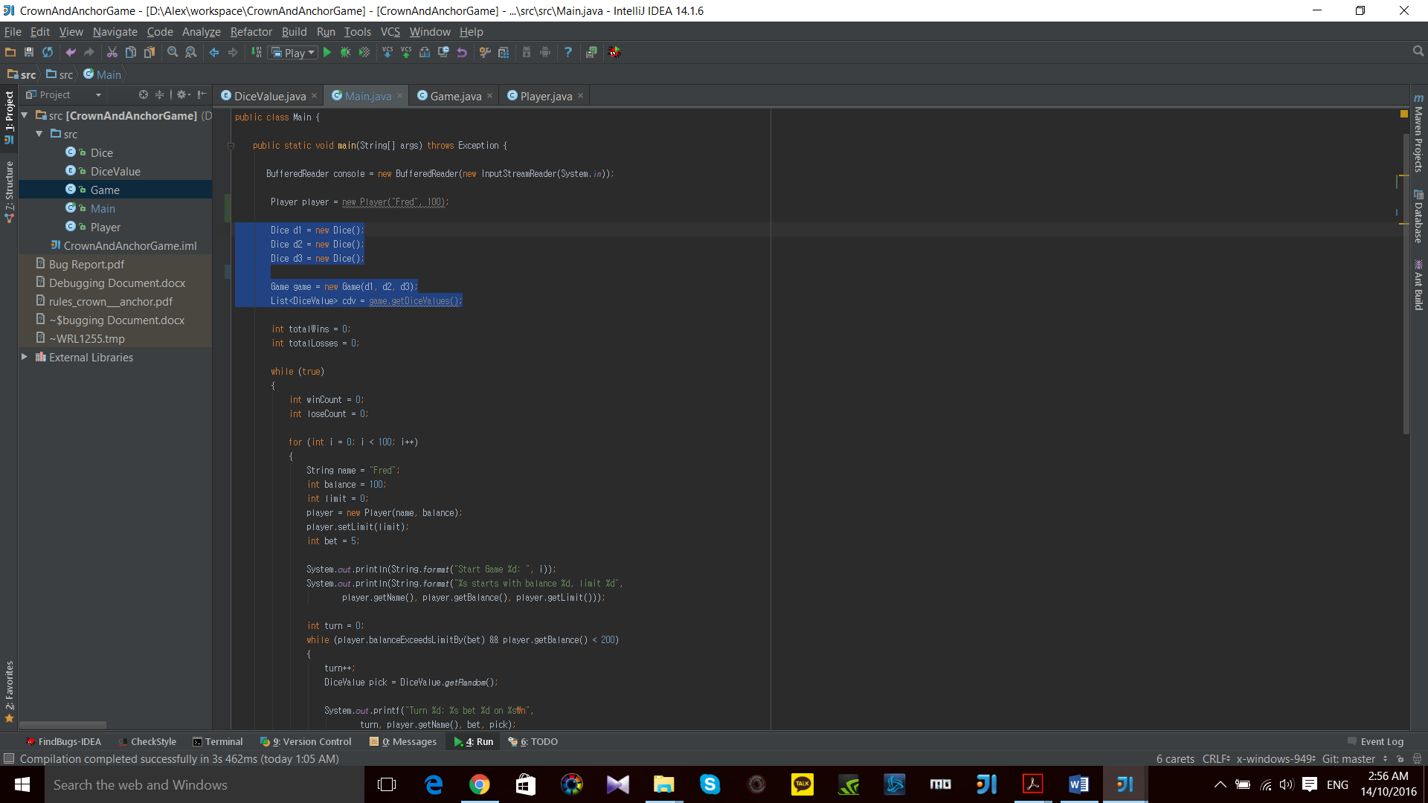

1. **Creating new Dice() outside of the loop for ‘game turn’**

Dice d1 = new Dice();  
Dice d2 = new Dice();  
Dice d3 = new Dice();

**\* New Dice(); should be in while loop in order to produce different value for each game.**

1. **Creating a new Game(d1, d2, d3) outside of the loop**

Game game = new Game(d1, d2, d3);

**\* New Game has to be declared in while loop in order to take new Dices’ Value.**

1. **Creating a List of Dice Value outside of the loop**

List<DiceValue> cdv = game.getDiceValues();

**\* Every Game has a different list of dice values. It should be declared in while loop.**

## 2. Game Pay Out at Correct Level

### Automated Testing Class and method

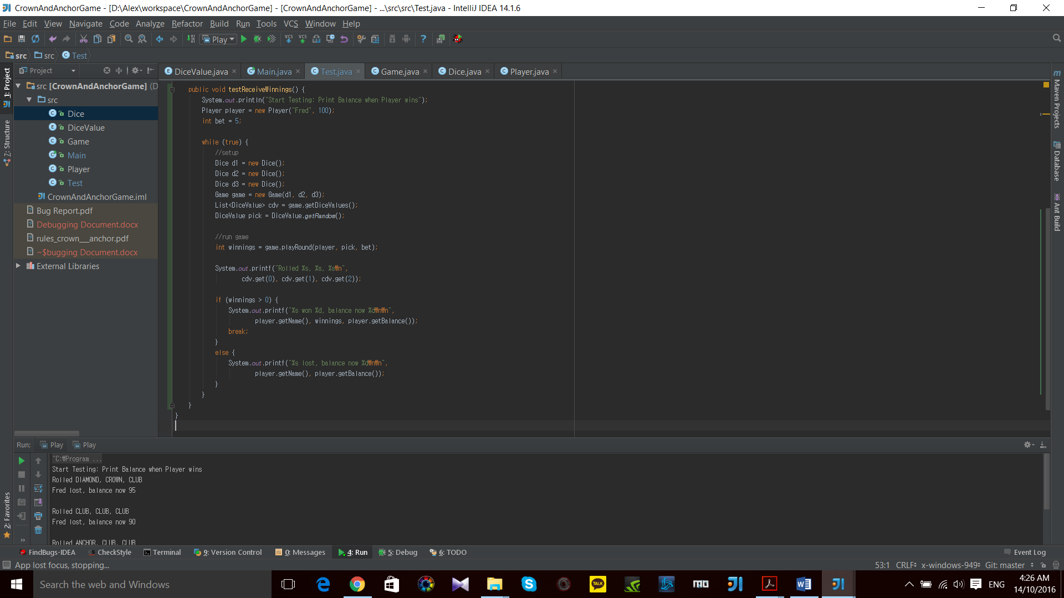

### Testing Result

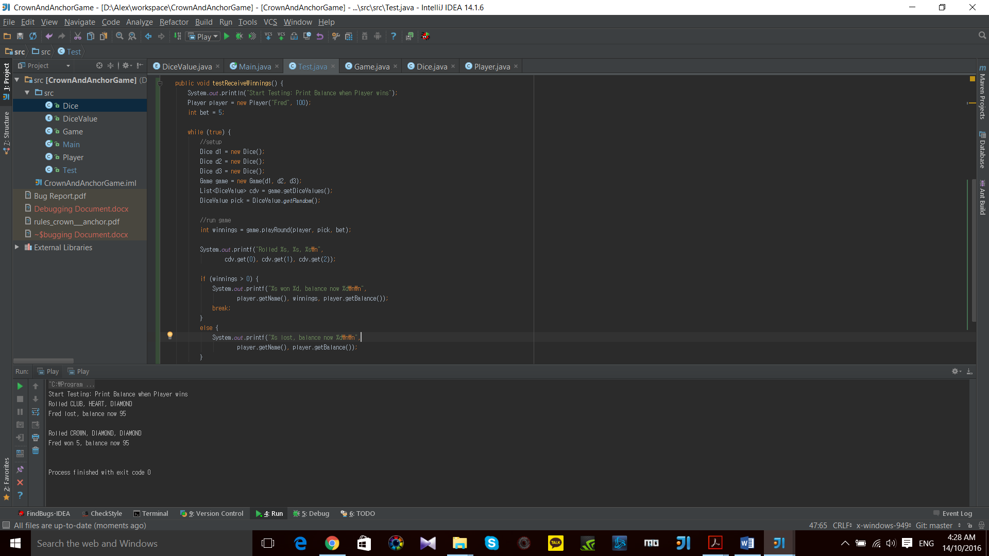

**\* When player wins, player does not get the betting money back but only winnings.**

### Origin of bug found

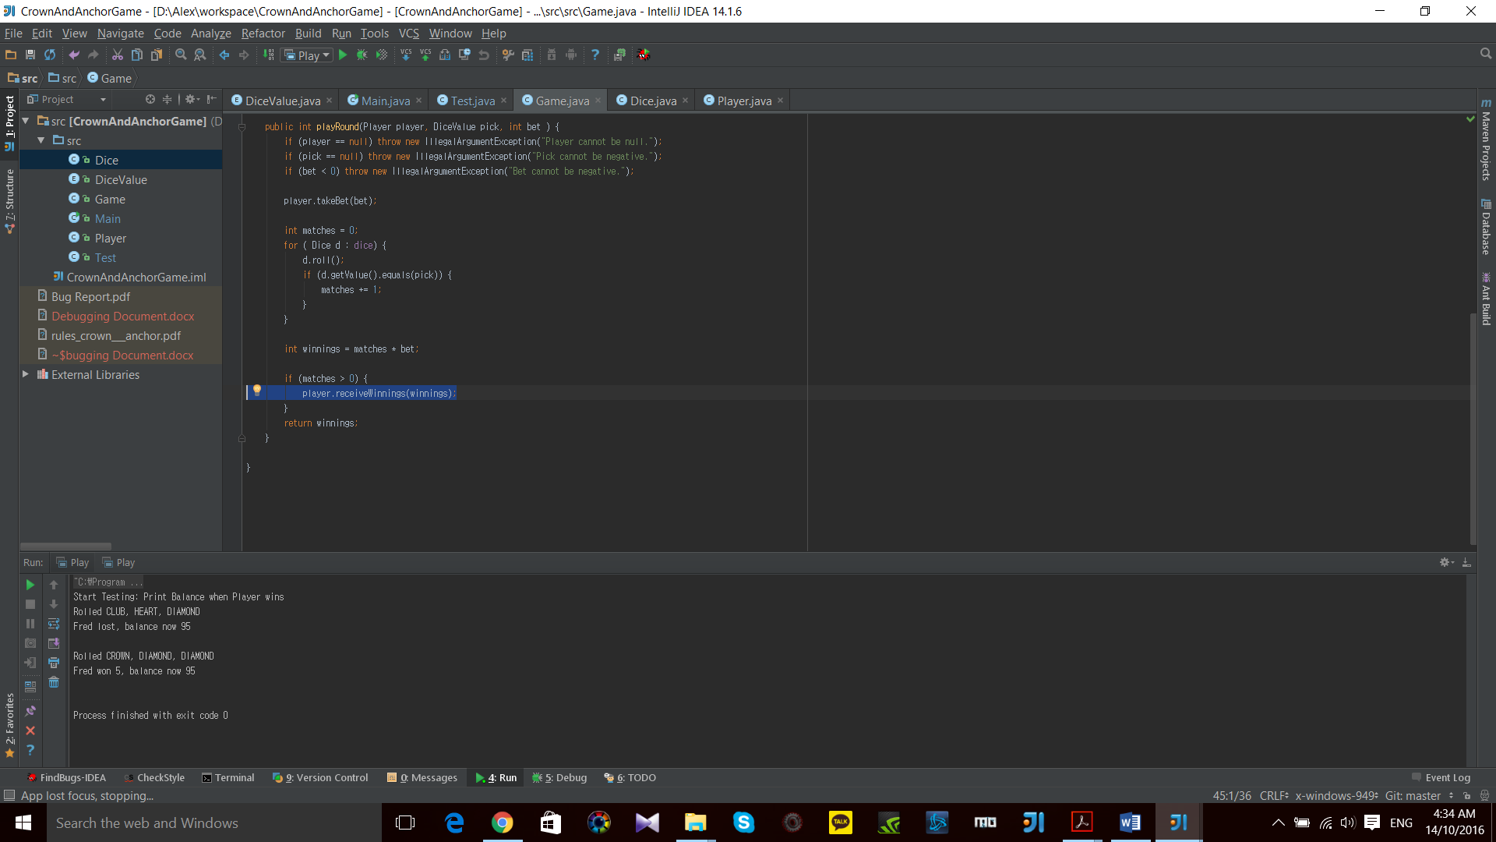

1. **Player only gets to receive winnings without betting cost**

player.receiveWinnings(winnings);

**\* int winnings = matches * bet; However, player.receiveWinnings(winnings); which excludes money that Player bet.**

## 3. Game Ends When Reached Betting Limit

### Automated Testing Class and method

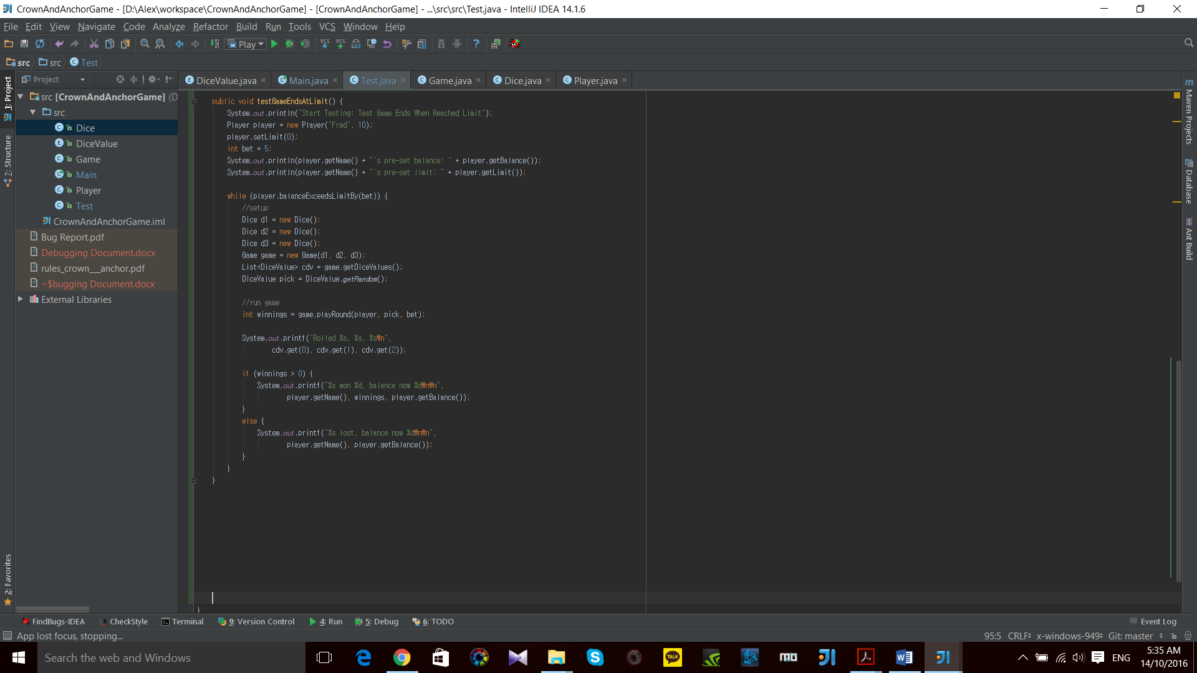

### Testing Result

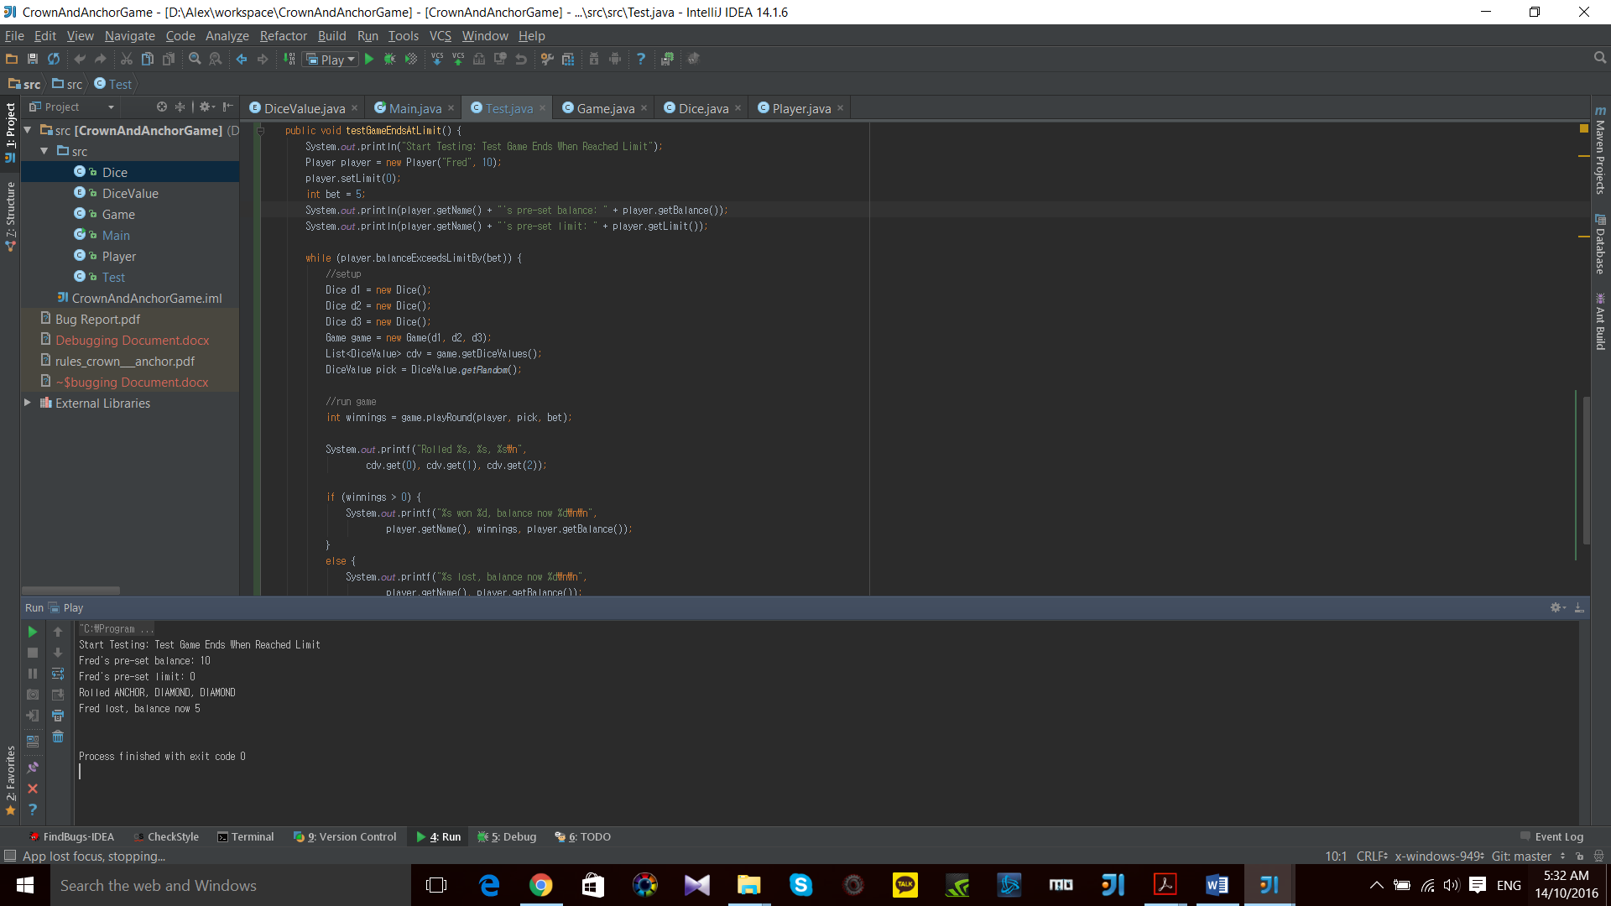

**\* Game ends when Player still has enough balance for another round.**

### Origin of bug found

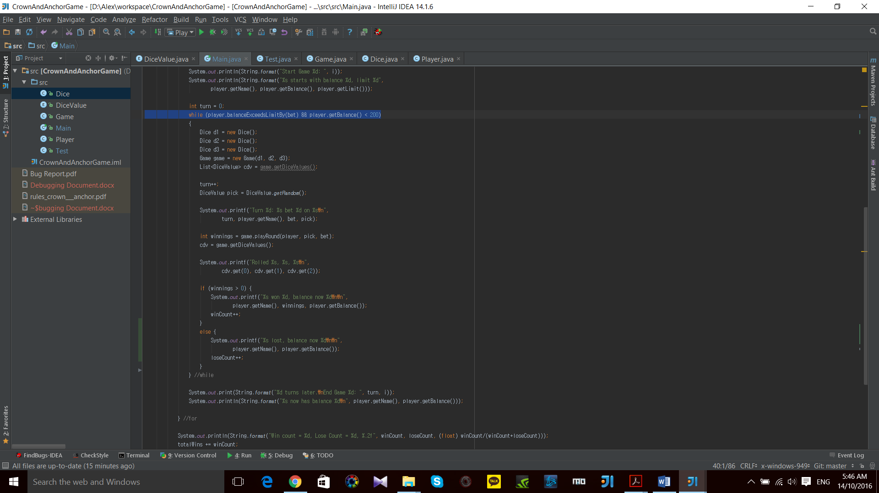

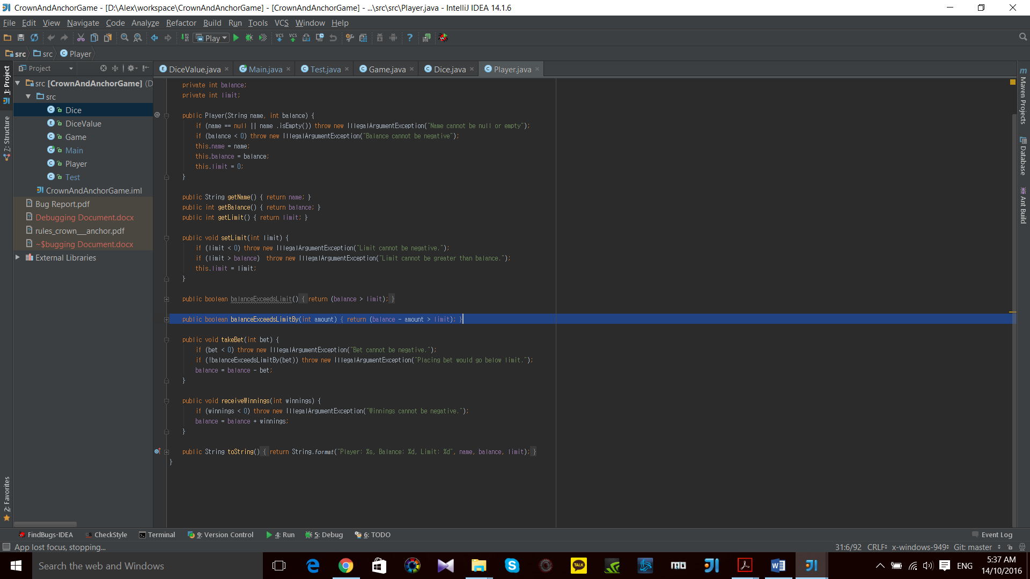

1. **Player can playRound() only while ‘balance – bet > limit’**

**\* When Player’s ‘balance – bet == limit’, this method will break; while loop**

## 4. Odds in The Game Appears To Be Correct

### Automated Testing Class and method

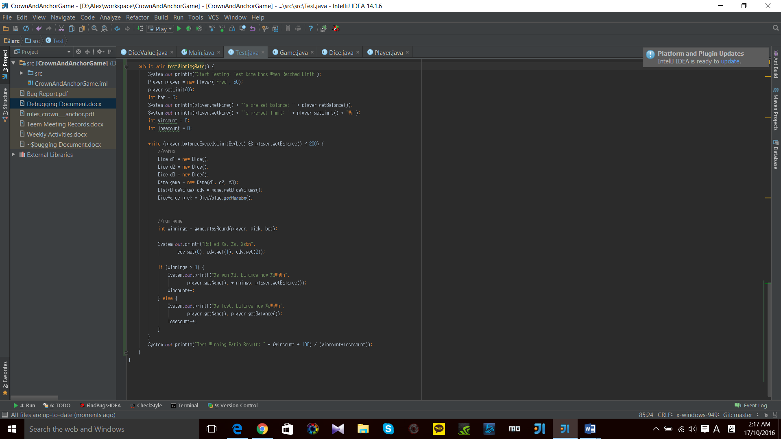

### Testing Result

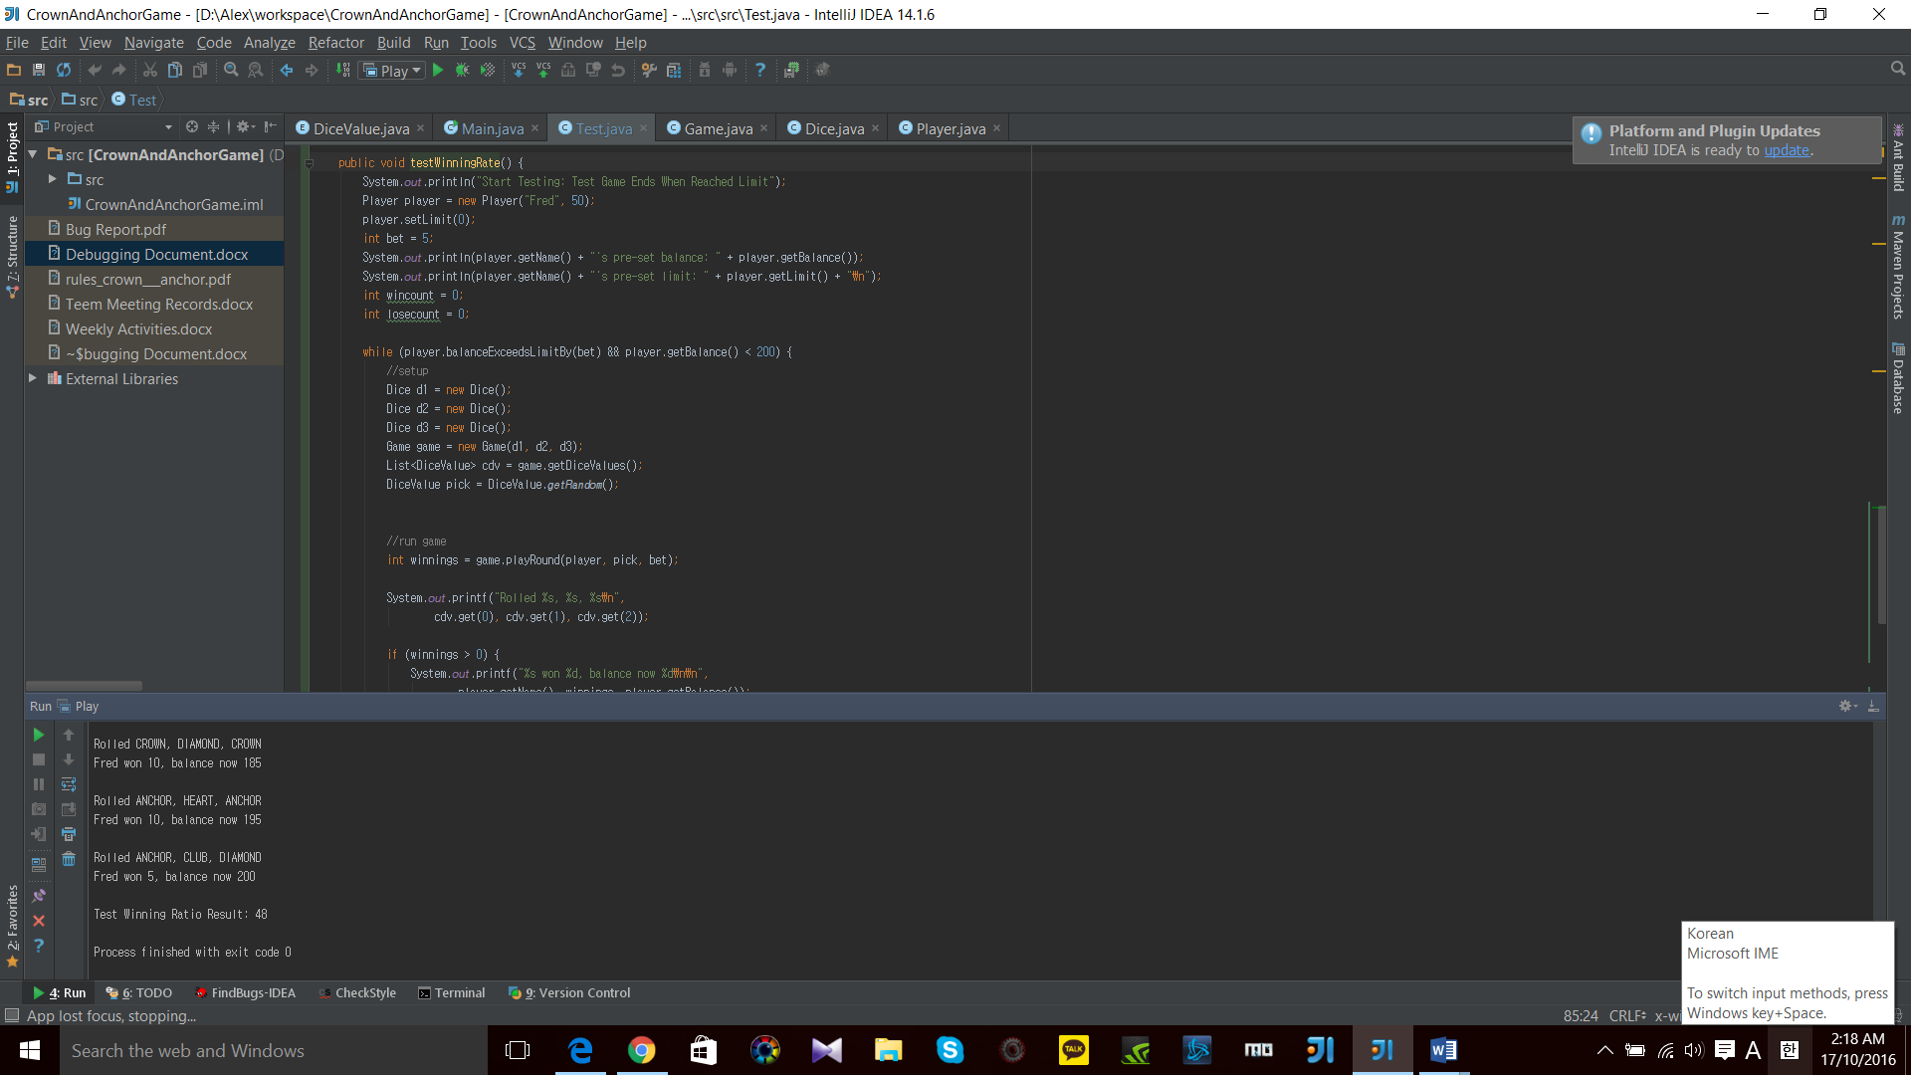

### Origin of bug found

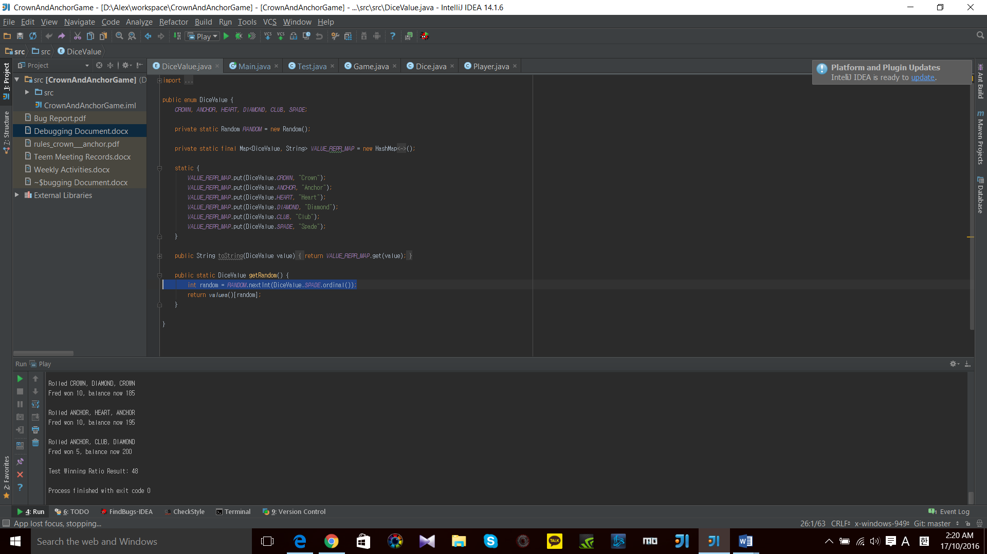

1. **int random do not provide dice value “SPADE”**

**\* RANDOM.nextInt(DiceValue.SPADE.ordinal()) does not include 6th Dice Value (“SPADE”)**

# **Resolution**

## 1. Produce Random Dice Values

### Fixed Code

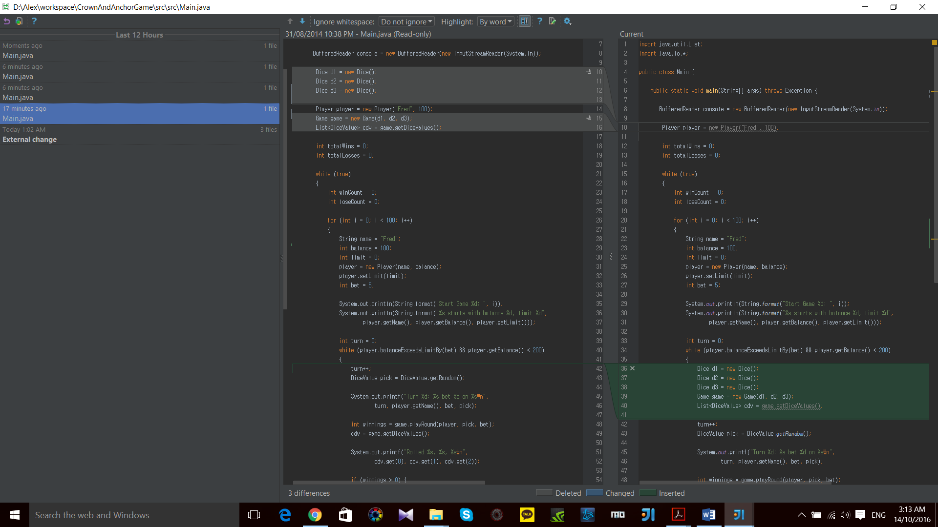

### Fixed Output

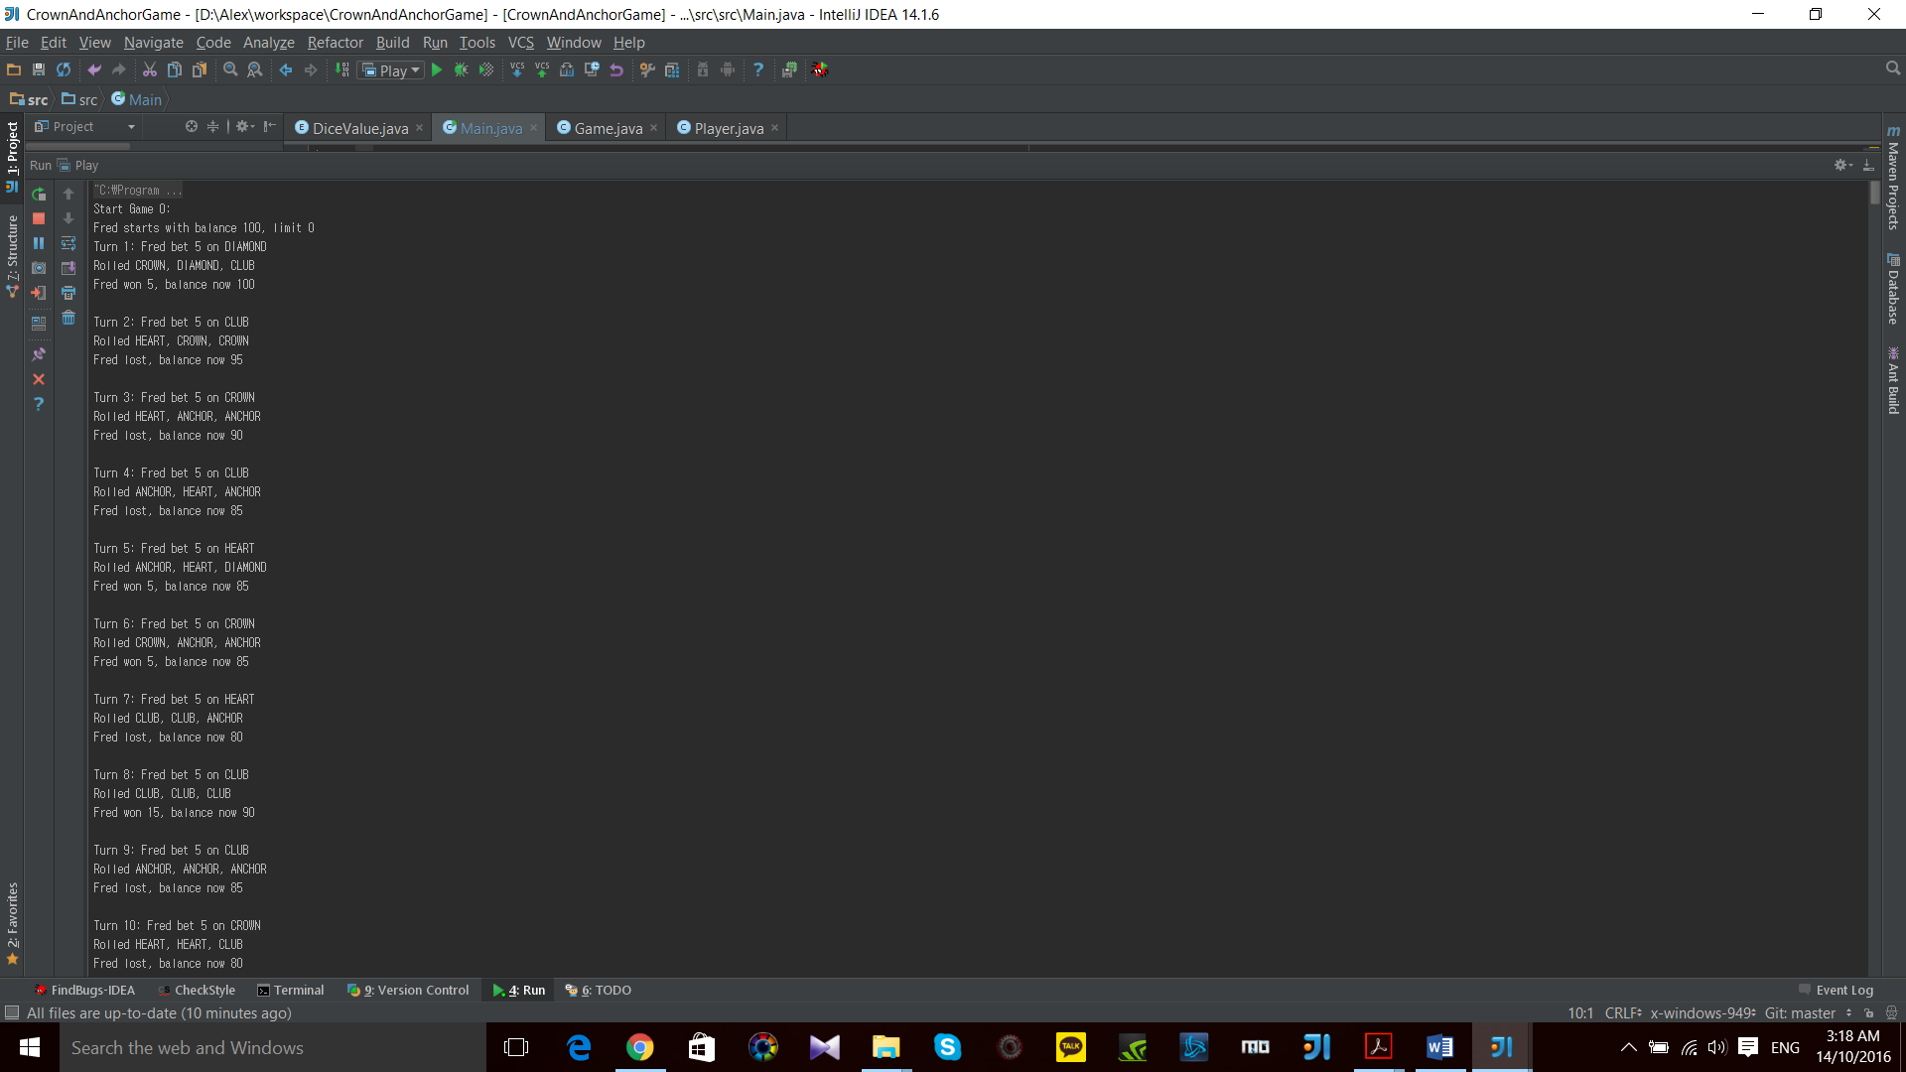

## 2. Game Pay Out at Correct Level

### Fixed Code

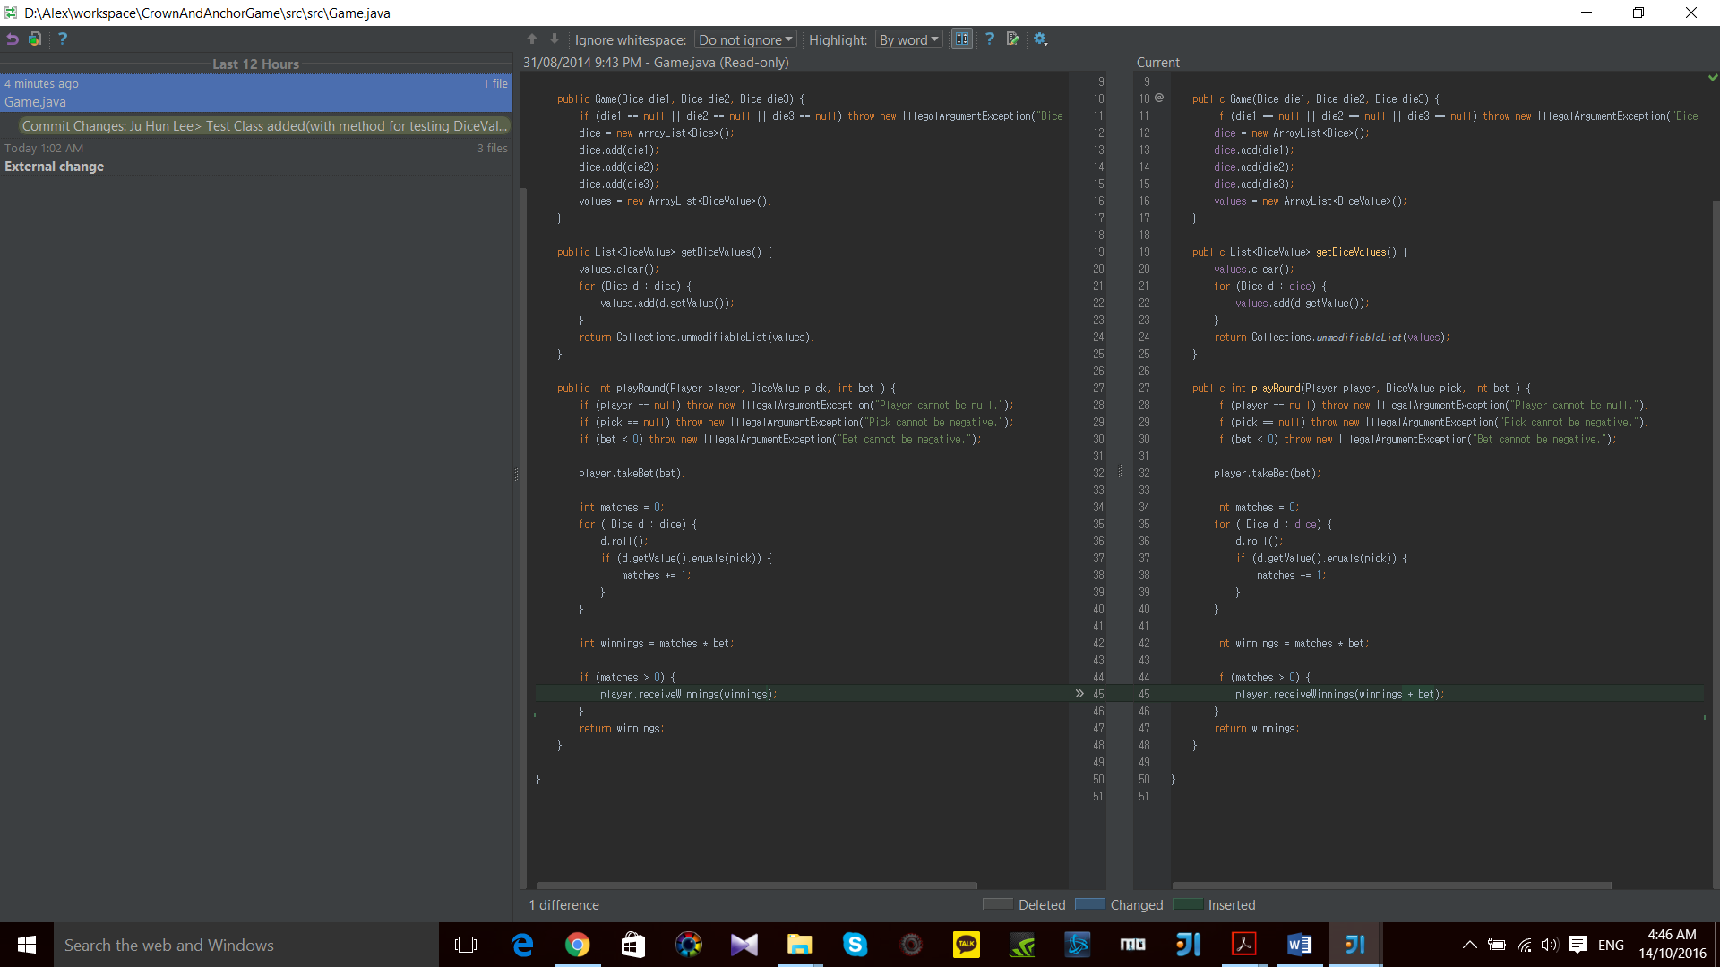

### Fixed Output

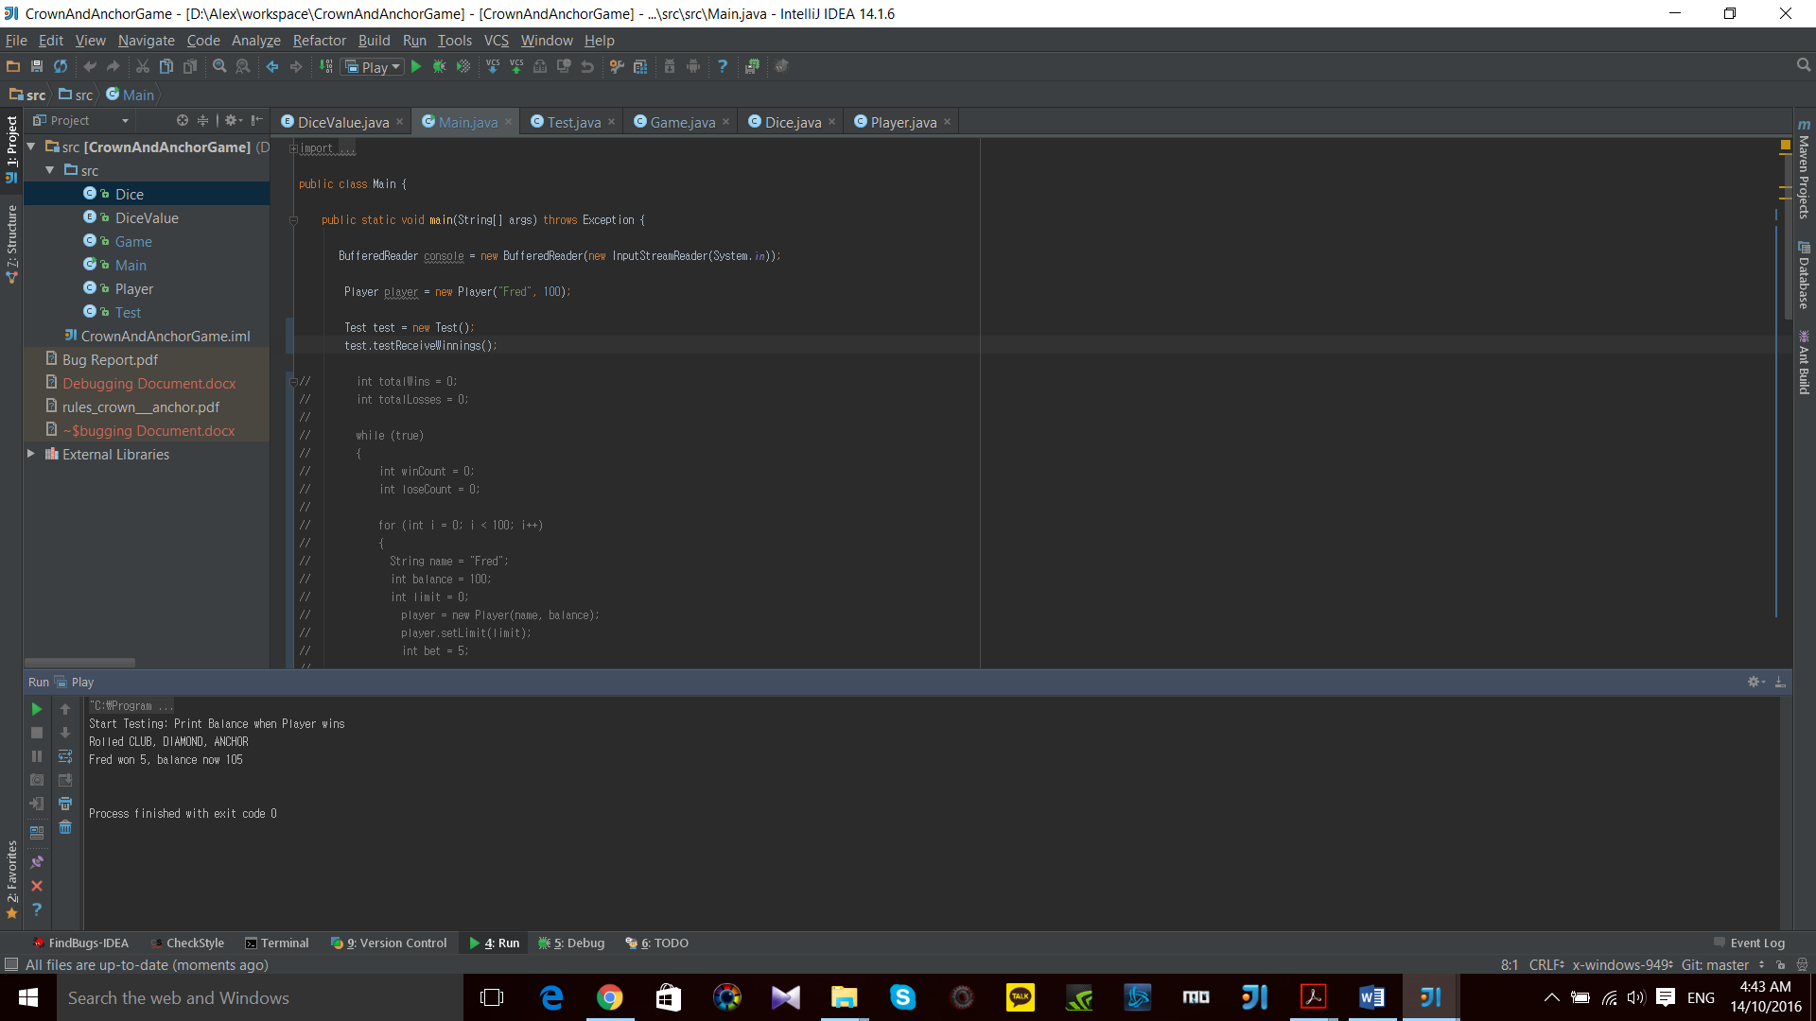

## 3. Game Ends When Reached Betting Limit

### Fixed Code

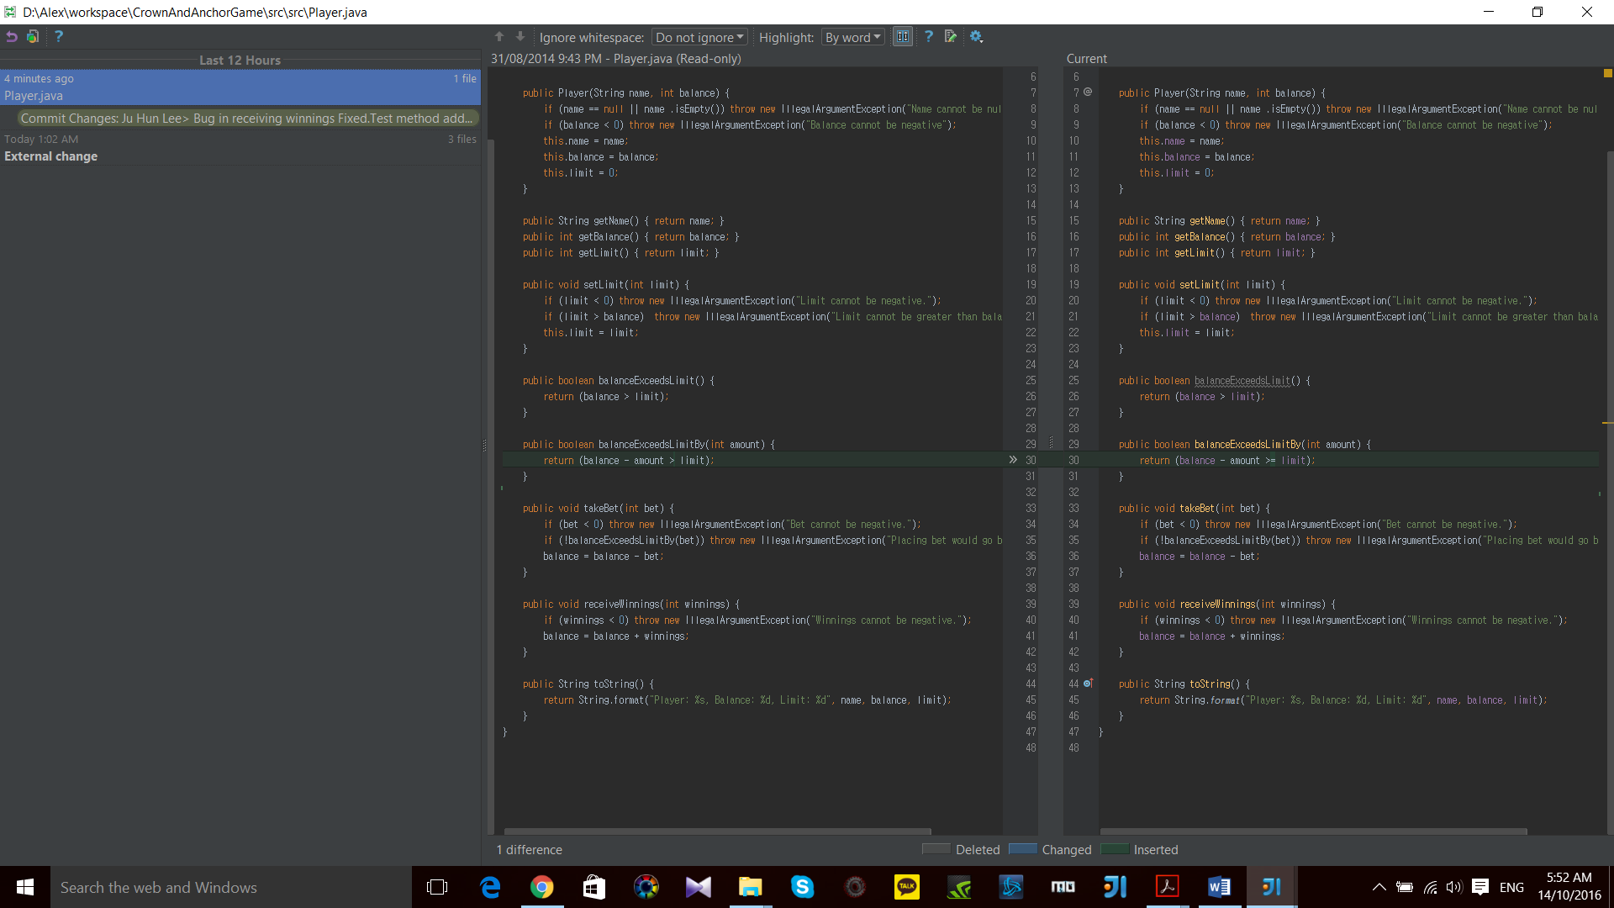

### Fixed Output

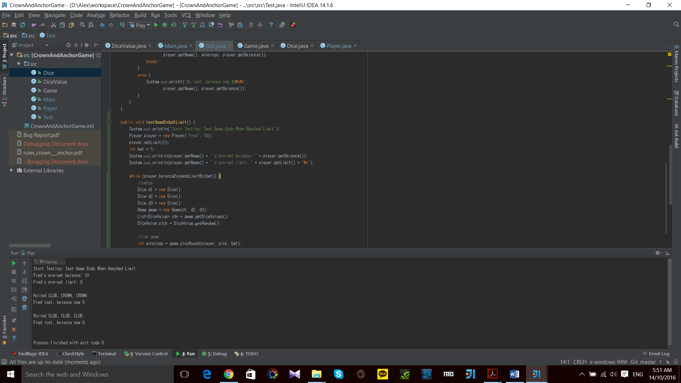

## 4. Odds in The Game Appears To Be Correct

### Fixed Code

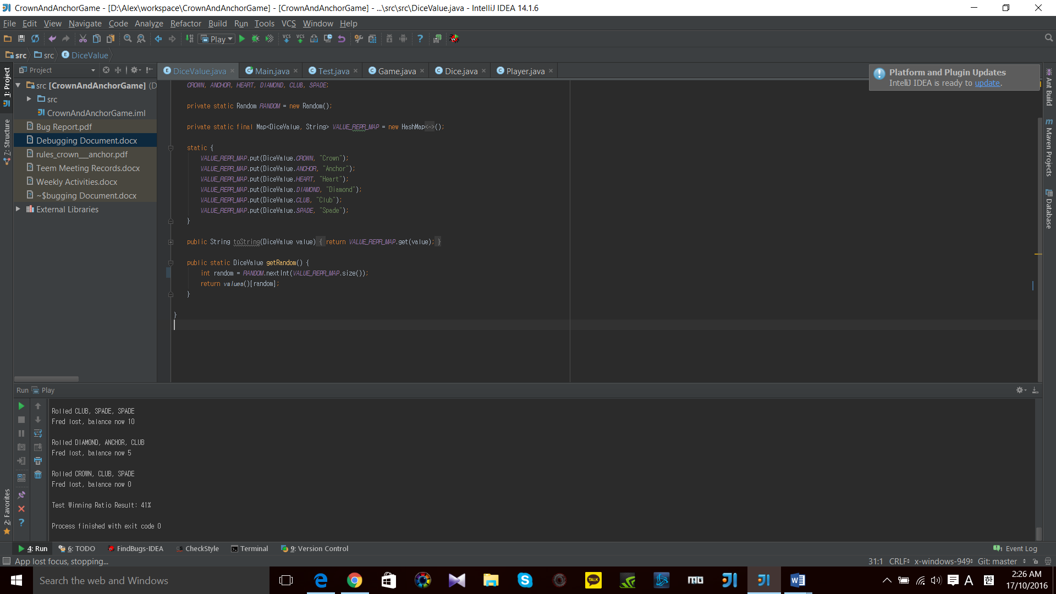

### Fixed Output

